**TITLE**

Eye Care for Houston’s Underserved Communities

**AUTHORS**

Daniel C. Brock1,2, Mallika Tyagi3, Tiffany Ramos4, Monica Guerrero4, Claudia K. Tischler1,2, Victoria Chen1, Damien Kelly5, Venus Gines6, Nelly Elorza6, Juliana Zapata7, Mary L. Vaughan1,8, Ravi K. Chundru1,8, Dana Clark1,8

**AFFILIATIONS**

1School of Medicine, Baylor College of Medicine, Houston, TX 77030, USA.

2Medical Scientist Training Program, Baylor College of Medicine, Houston, TX 77030, USA.

3McGovern Medical School, The University of Texas Health Science Center at Houston, Houston, TX 77030, USA.

4Prevent Blindness Texas, Houston, TX 77018, USA.

5Open Gate Homeless Ministries, Houston, TX 77006, USA.

6Dia De La Mujer Latina, 6400 High Star Dr, Houston, TX 77074, USA.

7Casa Maria, 6101 Edgemoor Dr, Houston, TX 77081, USA.

8Healthcare for the Homeless Houston, Houston, TX 77002, USA.

**BACKGROUND AND SIGNIFICANCE**

Description: Motivation for project and project description with special focus on the incorporation of humanism in medicine.

Evaluation Criteria: (1) How pressing is the need for the proposed project? (2) How strongly does the project incorporate humanism as defined: “*Humanism in healthcare is characterized by a respectful and compassionate relationship between physicians, as well as all other members of the healthcare team, and their patients. It reflects attitudes and behaviors that are sensitive to the values and the cultural and ethnic backgrounds of others.*”

Houston is a large metropolitan area that harbors diverse communities, yet a substantial population faces challenges in accessing vision care, hindering their ability to fully participate in daily life and opportunities due to limited eyesight. Among the spectrum of unmet health needs, difficulty in acquiring eyeglasses and eye care ranks as one of the most pervasive in populations experiencing housing instability[1](https://www.zotero.org/google-docs/?DHTgcC). Uncorrected visual impairment may exacerbate a person’s health conditions, as the process of navigating health systems and acquiring health information becomes difficult to impossible[2](https://www.zotero.org/google-docs/?srsxCJ). Several efforts exist to promote affordable healthcare and job opportunities for those with housing instability; however, this effort is thwarted if the target population cannot read their medication bottles, use their phones, or read pamphlets. Furthermore, people experiencing housing instability are more likely to spend significant amounts of time outdoors in direct sunlight, which is a risk factor for developing cataracts[3,4](https://www.zotero.org/google-docs/?64zaDg). We aim to address these risk factors and communication barriers by providing free eyeglasses, sunglasses, and protective cases for eligible patients experiencing housing instability.

Local volunteer initiatives aim to address the healthcare needs of Houston’s underserved communities. The Houston Outreach Medicine Education & Social Services (HOMES) Clinic is the only student-run clinic in Houston and a program of Healthcare for the Homeless-Houston (HHH)[5,6](https://www.zotero.org/google-docs/?RHhvm9). It aims to address medical and social concerns of a general population experiencing unstable housing. Open Gate Homeless Ministries provides dinners, clothing, and various health screenings to a predominantly LGBTQ+ youth population[7](https://www.zotero.org/google-docs/?VrPSlf). Casa Maria is a local clinic for immigrants lacking health insurance, serving a predominantly Spanish-speaking Hispanic population. Together, these clinics represent a diverse group of clients who can directly benefit from vision screenings and donation of glasses.

The ophthalmology interest groups (OIGs) at Baylor College of Medicine (BCM) and McGovern Medical School have previously led successful vision screenings at HOMES Clinic, Open Gate Homeless Ministries, and Casa Maria. This was done in partnership with Prevent Blindness Texas[8](https://www.zotero.org/google-docs/?GSpyk1), who provide vision screening machines that measure near and distance visual acuity. In the fall of 2023, HOMES Clinic introduced an ophthalmology volunteering program, engaging medical students from BCM and McGovern to assist Dr. Ravi Chundru, a volunteer ophthalmologist, in delivering eye care to patients experiencing housing instability. This program not only provided students with valuable insights into the vision needs of Houston’s underserved population, but also resulted in a generous donation of reading glasses from Mary Vaughan. As the OIGs integrated the provision of reading glasses for eligible patients into their vision screenings, a remarkable improvement in patient satisfaction became evident. Yet, there is still a need for continued progress as our resources are limited. Currently, our ability to offer glasses is restricted by the absence of specific prescriptions for reading glasses, limiting the number of eligible clients who can benefit from our program. Furthermore, our clients can greatly benefit from protective cases for their glasses so they do not get damaged or lost. By offering a wider range of glasses prescriptions, sunglasses, and protective cases, we aim to further expand on our progress in addressing the vision needs of Houston’s underserved people.

**BROADER IMPACTS**

Description: Projected scale and longevity of impact of proposed project.

Evaluation Criteria: (1) How broad and deep is the proposed impact of the project, and how likely will the project achieve its projected impact? (2) How sustainable is the impact of the project given the provided budget?

Our project aims to serve three major populations: a general population experiencing unstable housing at HOMES Clinic, younger LGBTQ+ individuals at OpenGate Homeless Ministries, and uninsured Hispanic populations at Casa Maria (**Supplemental Table 1**). We begin our vision screening process by having self-identified clients complete the Prevent Blindness of Texas’ vision screening form (**Supplemental Figure 1**). For those requiring assistance, volunteers are available to read the form aloud and aid in its completion. Next, our clients’ visual acuity is evaluated using a vision screening machine operated by a trained volunteer from Prevent Blindness Texas. Eligibility is determined if clients report poor near vision or symptoms of presbyopia, an age-related gradual loss of the eye’s ability to focus on close objects[9](https://www.zotero.org/google-docs/?AXCB86). If these criteria are met, eligible clients are fitted with reading glasses. The selection of the prescription for reading glasses is guided by a vision test chart held approximately 12 inches away from the clients’ eyes (**Supplemental Figure 2**). Once the client is satisfied with a pair of reading glasses, clients keep their pair of glasses, accompanied with a protective case and a pair of sunglasses to improve long-term eye health.

For clients exhibiting poor distance vision or multiple risk factors for developing eye diseases, we facilitate referrals to practicing optometrists/ophthalmologists. A client’s risk for developing eye diseases, such as glaucoma, is determined by the Prevent Blindness Texas vision screening form’s risk assessment section (**Supplemental Figure 1**). To aid clients requiring referrals, we compiled a list of vision clinics, prioritizing programs which accept uninsured/underinsured individuals (**Supplemental Table 2**). Our list, available as a printed handout, includes Dr. Ravi Chundru’s ophthalmology clinic and Spanish-speaking clinics, featuring multiple contact methods, such as website addresses, phone numbers, and QR codes. In addition to addressing our clients’ immediate vision challenges, our project promotes enduring solutions by encouraging clients to seek affordable optometry/ophthalmology clinics. Comparable research conducted by different institutions reveals a large unmet demand for glasses among individuals facing housing instability, with subsequent high levels of satisfaction reported upon the donation of glasses[10–13](https://www.zotero.org/google-docs/?OmOpaw). By aligning our volunteer program with three organizations covering diverse demographic groups, we envision making a tangible improvement in the quality of life of Houston’s underserved communities.

**PROJECT SCHEDULE, MILESTONES, AND BUDGET**

Description: The project should be completed absolutely no later than June 1, 2024. Please provide a timeline with monthly milestones starting from March 1, 2024 with approximated expenditures per month. Award budgets may range anywhere between $100 and $500 total.

Evaluation Criteria: (1) How feasibly can the project be completed in the time span specified in the proposal? (2) How feasibly can each project milestone be achieved? (3) How detailed and well-informed is the cost of each budget item (cost of each item should be well-informed by real estimates provided in the supplemental data section)?

Schedule

During the three-month project time period, we plan to perform three vision screening events, one per month. Our screening at HOMES Clinic will occur at a health fair during the month of March, 2024. Our screening at Casa Maria will occur on [date / month]. Lastly, our screening with OpenGate Homeless Ministries will occur on [date / month].

Milestones

During our vision screenings, we will measure our clients’ visual acuity and other demographic factors through the Prevent Blindness Texas vision screening form. We will also measure our clients’ satisfaction with their reading glasses and/or referrals.

Budget

Our budget includes reading glasses bundled with protective cases and sunglasses (**Supplemental Table 3**). This includes 10 glasses per prescription, including +1.0, +1.5, +2.0, +2.5, +3.0, +3.5, and +4.0 prescriptions for a total of 70 glasses accompanied with protective cases. Our budget also includes 70 sunglasses. Our total budget, including taxes, amounts to approximately $469.21 using Amazon’s current pricing and free shipping. Any extra equipment will be stored in a secure locked cabinet at the HOMES Clinic and utilized in future vision screening events.

**SUPPLEMENTAL DATA**

**Supplemental Table 1:** Demographics and Visual Acuity for Houston’s Underserved Community. Numbers represent number of people screened with percentages in parentheses.

|  |  |  |  |  |  |
| --- | --- | --- | --- | --- | --- |
|  |  | **HOMES (n = 19)** | **OpenGate (n = 12)** | **Casa Maria (n = 18)** | **Dia De La Mujer Latina (n = 76)** |
| **Age** | 18-29 | 3 (15.8) | 6 (50.0) | 1 (5.6) | 5 (6.6) |
|  | 30-49 | 6 (31.6) | 4 (33.3) | 10 (55.6) | 45 (59.2) |
|  | 50-64 | 8 (42.1) | 2 (16.7) | 7 (38.9) | 20 (26.3) |
|  | 65+ | 2 (10.5) | 0 (0.0) | 0 (0.0) | 6 (7.9) |
| **Sex** | Male | 10 (52.6) | 11 (91.7) | 3 (16.7) | 9 (11.8) |
|  | Female | 8 (42.1) | 1 (8.3) | 15 (83.3) | 67 (88.2) |
|  | Transgender | 1 (5.3) | 0 (0.0) | 0 (0.0) | 0 (0.0) |
| **Ethnicity** | Caucasian | 4 (21.1) | 1 (8.3) | 3 (16.7) | 0 (0.0) |
|  | African American | 7 (36.8) | 6 (50.0) | 0 (0.0) | 1 (1.3) |
|  | Hispanic/Latino | 5 (26.3) | 3 (25.0) | 13 (72.2) | 59 (77.6) |
|  | Native American | 0 (0.0) | 0 (0.0) | 0 (0.0) | 7 (9.2) |
|  | Multiple | 2 (10.5) | 0 (0.0) | 0 (0.0) | 5 (6.6) |
|  | Other | 1 (5.3) | 1 (8.3) | 2 (11.1) | 1 (1.3) |
|  | No Response | 0 (0.0) | 1 (8.3) | 0 (0.0) | 3 (3.9) |
| **Insurance** | Uninsured | 12 (63.2) | 12 (100.0) | 17 (94.4) | 57 (75.0) |
|  | Private | 0 (0.0) | 0 (0.0) | 0 (0.0) | 1 (1.3) |
|  | Medicare | 1 (5.3) | 0 (0.0) | 0 (0.0) | 0 (0.0) |
|  | Medicaid | 3 (15.8) | 0 (0.0) | 0 (0.0) | 0 (0.0) |
|  | Goldcard | 2 (10.5) | 0 (0.0) | 0 (0.0) | 0 (0.0) |
|  | Affordable Care Act | 0 (0.0) | 0 (0.0) | 0 (0.0) | 1 (1.3) |
|  | Molina | 1 (5.3) | 0 (0.0) | 0 (0.0) | 0 (0.0) |
|  | No Response | 0 (0.0) | 0 (0.0) | 1 (5.6) | 17 (22.4) |
| **Last Eye Exam** | Less than 1 year | 1 (5.3) | 3 (25.0) | 1 (5.6) | 6 (7.9) |
|  | 1-2 years | 5 (26.3) | 3 (25.0) | 4 (22.2) | 19 (25.0) |
|  | 3-5 years | 5 (26.3) | 2 (16.7) | 4 (22.2) | 18 (23.7) |
|  | More than 5 years | 8 (42.1) | 3 (25.0) | 3 (16.7) | 15 (19.7) |
|  | Never | 0 (0.0) | 1 (8.3) | 5 (27.8) | 16 (21.1) |
|  | No Response | 0 (0.0) | 0 (0.0) | 1 (5.6) | 2 (2.6) |
| **Barriers to Care** | Cost | 7 (28.0) | 5 (38.5) | 6 (33.3) | 55 (64.7) |
|  | Lack of Transportation | 7 (28.0) | 3 (23.1) | 0 (0.0) | 2 (2.4) |
|  | Lack of Knowledge | 3 (12.0) | 0 (0.0) | 0 (0.0) | 5 (5.9) |
|  | Clinic Waiting Time | 1 (4.0) | 0 (0.0) | 0 (0.0) | 5 (5.9) |
|  | Fear of Doctors | 0 (0.0) | 0 (0.0) | 0 (0.0) | 1 (1.2) |
|  | Other | 0 (0.0) | 1 (7.7) | 1 (5.6) | 5 (5.9) |
|  | None | 3 (12.0) | 3 (23.1) | 5 (27.8) | 4 (4.7) |
|  | No Response | 4 (16.0) | 1 (7.7) | 6 (33.3) | 8 (9.4) |
| **Distance Visual Acuity** | 20/20 | 4 (10.5) | 1 (4.2) | 10 (27.8) | 14 (9.2) |
|  | 20/30 | 4 (10.5) | 4 (16.7) | 5 (13.9) | 24 (15.8) |
|  | 20/40 | 4 (10.5) | 2 (8.3) | 9 (25.0) | 20 (13.2) |
|  | 20/50 | 3 (7.9) | 0 (0.0) | 6 (16.7) | 23 (15.1) |
|  | 20/70 | 3 (7.9) | 0 (0.0) | 2 (5.6) | 27 (17.8) |
|  | 20/100 | 4 (10.5) | 1 (4.2) | 1 (2.8) | 11 (7.2) |
|  | 20/200 | 14 (36.8) | 15 (62.5) | 3 (8.3) | 27 (17.8) |
|  | unable to screen | 2 (5.3) | 1 (4.2) | 0 (0.0) | 6 (3.9) |
| **Near Visual Acuity** | 20/20 | 4 (10.5) | 3 (12.5) | 9 (25.0) | 4 (2.6) |
|  | 20/30 | 8 (21.1) | 6 (25.0) | 13 (36.1) | 16 (10.5) |
|  | 20/40 | 5 (13.2) | 2 (8.3) | 5 (13.9) | 20 (13.2) |
|  | 20/50 | 5 (13.2) | 1 (4.2) | 3 (8.3) | 23 (15.1) |
|  | 20/70 | 2 (5.3) | 2 (8.3) | 2 (5.6) | 33 (21.7) |
|  | 20/100 | 8 (21.1) | 2 (8.3) | 2 (5.6) | 49 (32.2) |
|  | 20/200 | 1 (2.6) | 7 (29.2) | 2 (5.6) | 0 (0.0) |
|  | unable to screen | 5 (13.2) | 1 (4.2) | 0 (0.0) | 7 (4.6) |

**Supplemental Table 2:** Low Resource Eye Clinics in Houston.

|  |  |  |
| --- | --- | --- |
| **Healthcare for the Homeless Houston**[**6**](https://www.zotero.org/google-docs/?0yObBr)   * <https://www.homeless-healthcare.org/> * 713-286-6125 * 1934 Caroline St, Houston, TX 77002 * Dr. Ravi Chundru’s eye clinic |  |  |
| **UH College of Optometry**[**14**](https://www.zotero.org/google-docs/?fdBCON)   * <https://eyecare.opt.uh.edu/> * 713-743-2020 * 4401 Martin Luther King Boulevard Houston, TX 77204 |  |  |
| **Legacy Community Health**[**15**](https://www.zotero.org/google-docs/?6Ao9Uj)   * <https://www.legacycommunityhealth.org/services/vision/> * Montrose:   + 832-548-5100   + 1415 California St. Houston, TX 77006 * Fifth Ward:   + 832-548-5400   + 3811 Lyons Ave. Houston, TX 77020 |  |  |
| **San Jose Clinic**[**16**](https://www.zotero.org/google-docs/?SVM9Ea)   * <https://www.sanjoseclinic.org/> * 713-228-9411 * 2615 Fannin St, Houston, TX 77002 * No insurance only |  |  |
| **Houston Eye Associates Foundation**[**17**](https://www.zotero.org/google-docs/?lav771)   * <https://foundation.houstoneye.com/> * 713-668-6828 * 7155 Old Katy Road, Suite S110 Houston, TX 77024 * Uninsured or underinsured only |  |  |

**Supplemental Table 3:** Project Budget

|  |  |  |
| --- | --- | --- |
| **Resource** | **Purchase Link** | **Price** |
| Reading Glasses, 5-pack with cases included  Strengths: +1.0, +1.5, +2.0, +2.5, +3.0, +3.5, +4.0 | <https://www.amazon.com/Gaoye-Reading-Blocking-Lightweight-Eyeglasses/dp/B0BCWRQ3QW/ref=sr_1_43?crid=1TUSLDQFGCB4&keywords=reading%2Bglasses%2Band%2Bcases%2Bin%2Bbulk&qid=1704363321&sprefix=reading%2Bglasses%2Band%2Bcases%2Bin%2Bbulk%2Caps%2C106&sr=8-43&th=1> | $18.99 per 5-pack.  2 orders for each prescription for a total of 10 glasses per prescription.  +1.0 glasses * 2 = $37.98  +1.5 glasses * 2 = $37.98  +2.0 glasses * 2 = $37.98  +2.5 glasses * 2 = $37.98  +3.0 glasses * 2 = $37.98  +3.5 glasses * 2 = $37.98  +4.0 glasses * 2 = $37.98  **Sum = $265.86** |
| Sunglasses, 10-pack | <https://www.amazon.com/Wholesale-Unisex-80s-Retro-Sunglasses/dp/B01M68J9YO/ref=sr_1_5?crid=OB9UZHDPL4C&keywords=sunglasses%2Buv%2Bprotection%2Bpack%2Badult&qid=1704179471&sprefix=sunglasses%2Buv%2Bprotectionpack%2Badult%2Caps%2C94&sr=8-5&th=1> | $24.00 per 10-pack  5 orders for a total of 50 sunglasses.  Sunglasses * 10 = $120.00  **Sum = $168.00** |
| Estimated Tax |  | **Tax = $35.35** |
|  |  | **Total = $469.21 (with free shipping)** |

**Supplemental Figure 1:** Prevent Blindness of Texas’ Vision Screening Form. This form is available in both English and Spanish.



**Supplemental Figure 2:** Vision Test Chart, Adopted from the Peepers Glasses Company[18](https://www.zotero.org/google-docs/?tHduar).

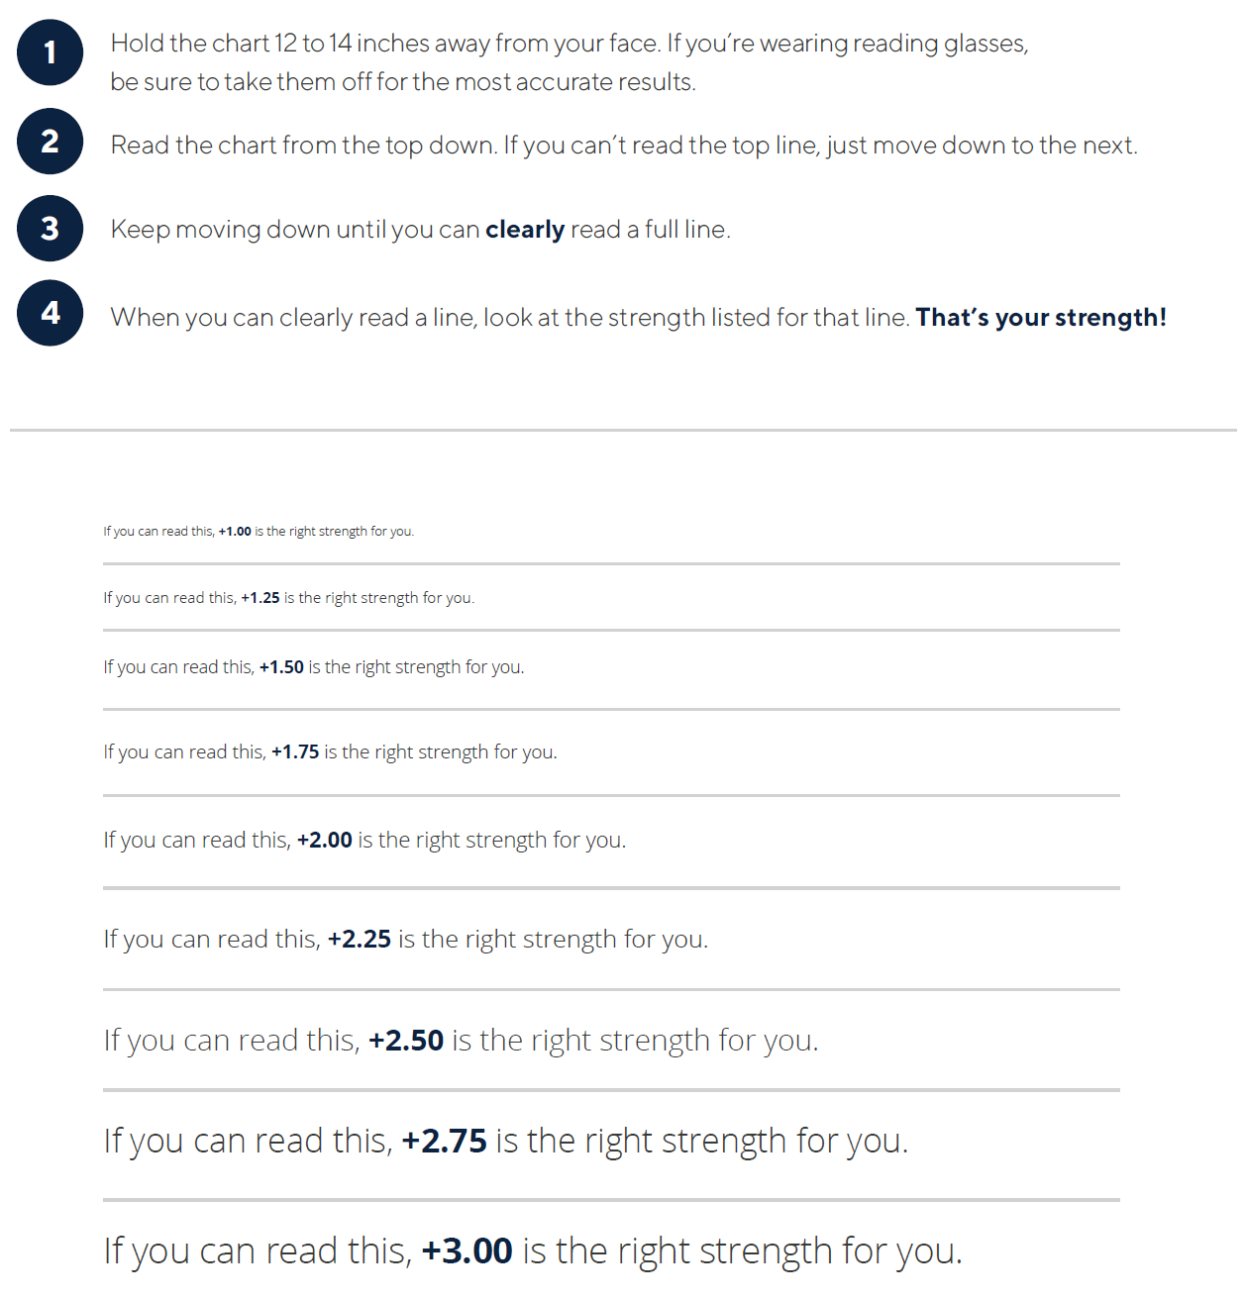

**REFERENCES**

[1. Baggett TP, O’Connell JJ, Singer DE, Rigotti NA. The Unmet Health Care Needs of Homeless Adults: A National Study. *Am J Public Health*. 2010;100(7):1326-1333. doi:10.2105/AJPH.2009.180109](https://www.zotero.org/google-docs/?GbHgAS)

[2. O’Day BL, Killeen M, Iezzoni LI. Improving Health Care Experiences of Persons Who Are Blind or Have Low Vision: Suggestions From Focus Groups. *Am J Med Qual*. 2004;19(5):193-200. doi:10.1177/106286060401900503](https://www.zotero.org/google-docs/?GbHgAS)

[3. Joseph A, Kindratt T, Pagels P, Gimpel N. Knowledge, Attitudes, and Practices Regarding Skin Cancer and Sun Exposure among Homeless Men at a Shelter in Dallas, TX. *J Canc Educ*. 2020;35(4):682-688. doi:10.1007/s13187-019-01511-8](https://www.zotero.org/google-docs/?GbHgAS)

[4. Taylor HR, West SK, Rosenthal FS, et al. Effect of Ultraviolet Radiation on Cataract Formation. *New England Journal of Medicine*. 1988;319(22):1429-1433. doi:10.1056/NEJM198812013192201](https://www.zotero.org/google-docs/?GbHgAS)

[5. HOMES Clinic. Accessed December 27, 2023. https://www.homesclinic.org](https://www.zotero.org/google-docs/?GbHgAS)

[6. Healthcare for the Homeless - Houston. Accessed January 14, 2024. https://www.homeless-healthcare.org](https://www.zotero.org/google-docs/?GbHgAS)

[7. OpenGate Homeless Ministries. Bering Open Gate. Accessed December 28, 2023. https://beringopengate.org/](https://www.zotero.org/google-docs/?GbHgAS)

[8. Prevent Blindness Texas. Published July 6, 2023. Accessed December 28, 2023. https://texas.preventblindness.org/](https://www.zotero.org/google-docs/?GbHgAS)

[9. Wolffsohn JS, Davies LN. Presbyopia: Effectiveness of correction strategies. *Progress in Retinal and Eye Research*. 2019;68:124-143. doi:10.1016/j.preteyeres.2018.09.004](https://www.zotero.org/google-docs/?GbHgAS)

[10. Gelberg L, Andersen RM, Leake BD. The Behavioral Model for Vulnerable Populations: application to medical care use and outcomes for homeless people. *Health Serv Res*. 2000;34(6):1273-1302.](https://www.zotero.org/google-docs/?GbHgAS)

[11. Lam J, Robertson K, Robertson W, Bernstein R. Improving Access to Vision Care for People Who are Homeless through Eyeglasses Recycling. *Journal of Health Care for the Poor and Underserved*. 2015;26(4):1359-1367. doi:10.1353/hpu.2015.0123](https://www.zotero.org/google-docs/?GbHgAS)

[12. Brown RT, Kiely DK, Bharel M, Mitchell SL. Geriatric Syndromes in Older Homeless Adults. *J GEN INTERN MED*. 2012;27(1):16-22. doi:10.1007/s11606-011-1848-9](https://www.zotero.org/google-docs/?GbHgAS)

[13. Berry JL, Cuzzo LM, Bababeygy SR, Quiros PA. Unmet need for corrective eyeglasses: results from a Los Angeles County Hospital survey. *Int Ophthalmol*. 2012;32(3):245-250. doi:10.1007/s10792-012-9561-1](https://www.zotero.org/google-docs/?GbHgAS)

[14. UH Health - Eye Care. Published September 2, 2021. Accessed January 14, 2024. https://eyecare.opt.uh.edu/](https://www.zotero.org/google-docs/?GbHgAS)

[15. Eye Doctor Houston TX | Optometry | Legacy Community Health. Accessed January 14, 2024. https://www.legacycommunityhealth.org/services/vision/](https://www.zotero.org/google-docs/?GbHgAS)

[16. San José Clinic. Accessed January 14, 2024. https://www.sanjoseclinic.org](https://www.zotero.org/google-docs/?GbHgAS)

[17. Houston Eye Associates Foundation. Accessed January 14, 2024. https://foundation.houstoneye.com/](https://www.zotero.org/google-docs/?GbHgAS)

[18. Peepers by PeeperSpecs. Accessed January 14, 2024. https://www.peepers.com/](https://www.zotero.org/google-docs/?GbHgAS)